Redux Initialization:

Following are the steps you have to take before start learning:

1) Firstly, install Node js
2) Secondly, create a new folder called Redux Demo or whatever you want and open VS code in it.
3) Thirdly, open terminal and run the command npm init –yes

The above command initialized the default package.json file with default settings.

4) Towards next step, run the command on terminal npm install redux. Now your VS Code looks like the following

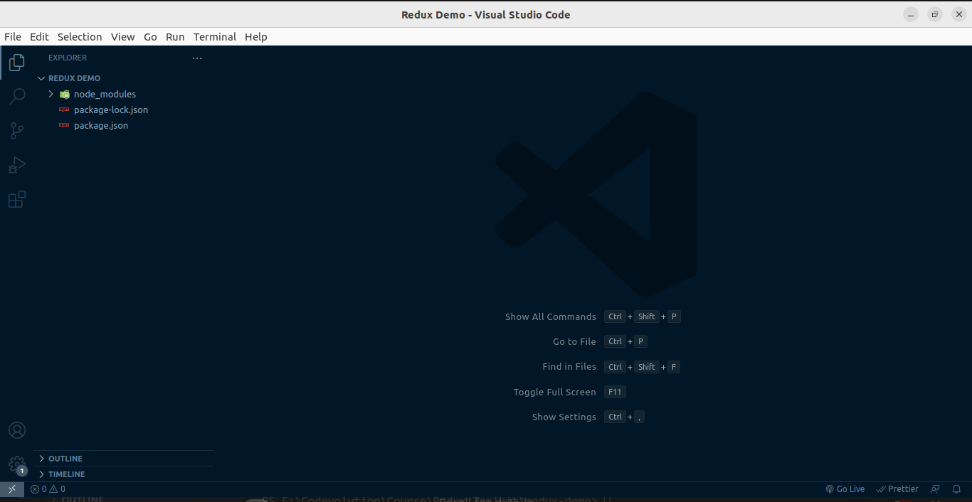

The fifth and final step is to create a javascript file to write code

After creating JS file write console.log("We are going to learn redux")

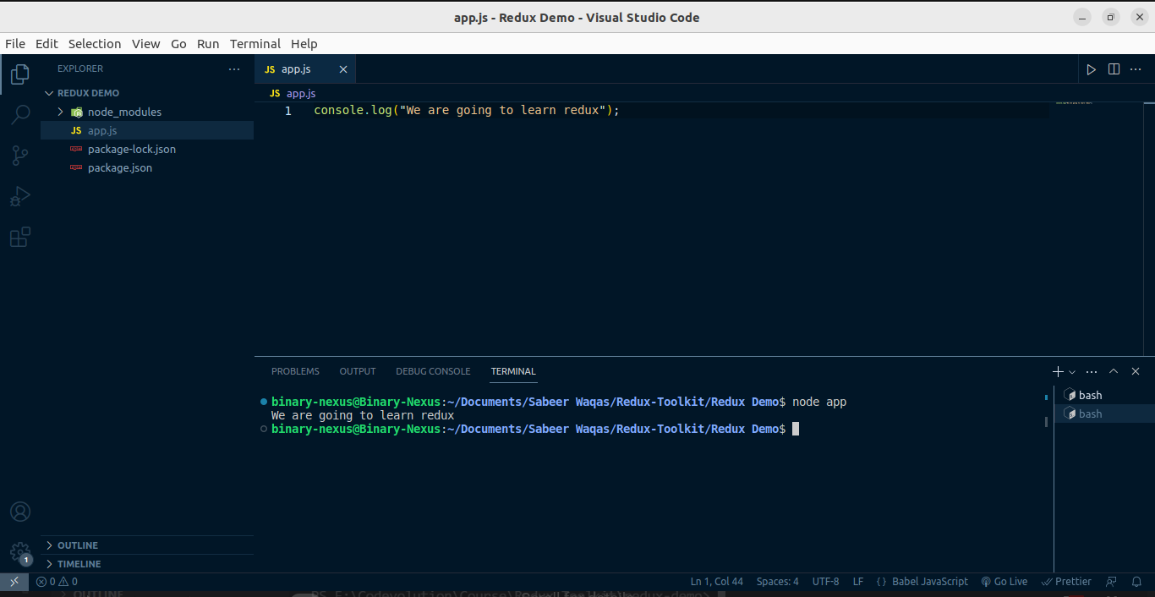
and open terminal write node your JS file name without JS extension.
Now your VS Code looks like the following
Now we are ready to start learning redux. See you in next content.

